The Beauty of “Financial Tree”
——An interview with the world's leading financial expert
Professor David X. Ding

INTERNATIONAL BUSINESS DAILY
Published by the Ministry of Commerce of the People’s Republic of China
November 7, 2007
By Guo Huihua

Studying economic and financial issues is actually studying the future: how to control for and transfer future risk. But the future is full of uncertainties; thus qualitative or quantitative analysis of the future presents the greatest challenge for mankind. It is the most valuable to foresee the future events before they take place.

From Challenging the Future ----International Financial Expert Predicts Chinese Economy by David X. Ding

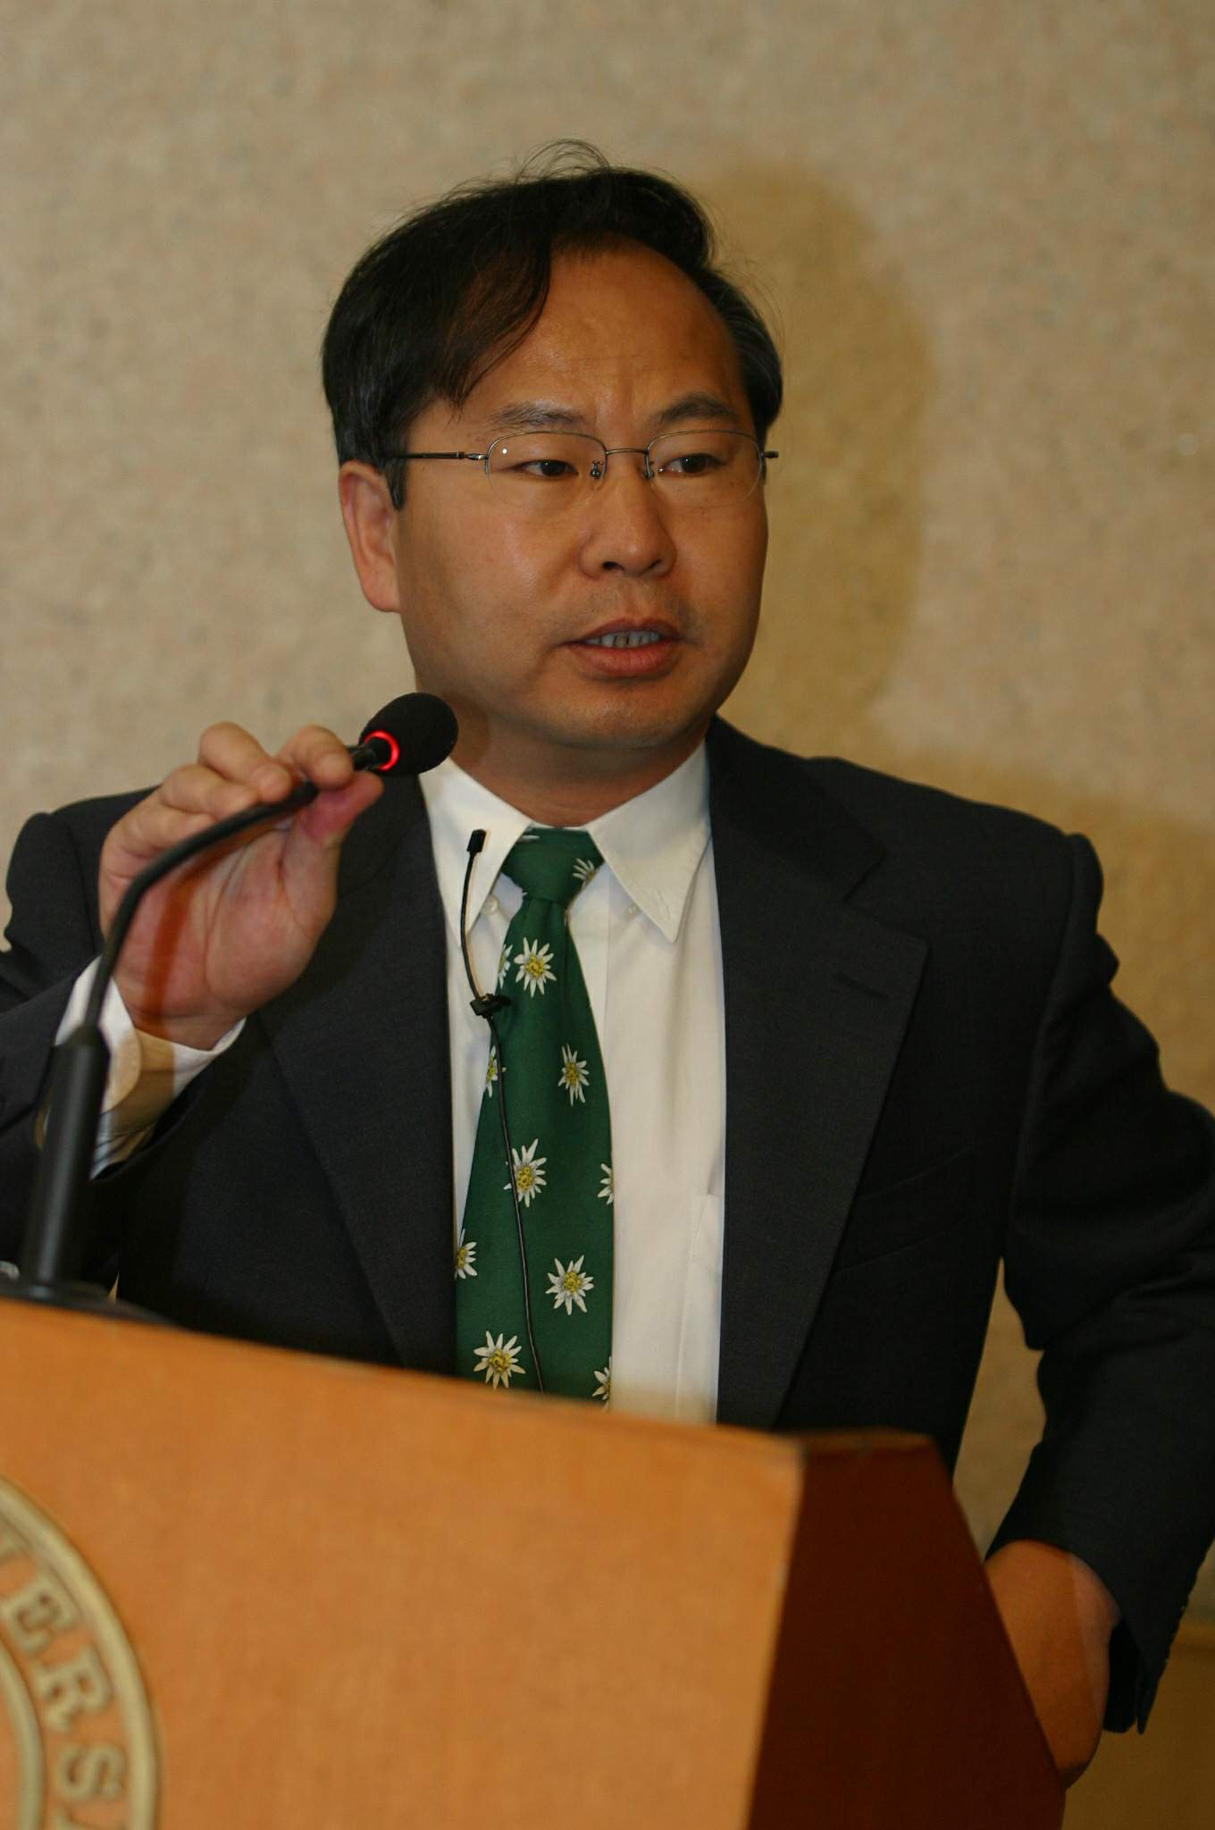
Financial Expert David X. Ding

In May, 2007, during an international financial conference held in Beijing, this reporter had the honor to meet the world-famous finance professor David X. Ding, and hear him lecture on “Financial Tree” theory. Like other members of the audience (which included both Chinese and foreigners), I became deeply attracted by the “Financial Tree” theory for its ability to turn complex financial knowledge into a system which is easy to digest and accept.

For more than 20 years, Prof. Ding has devoted himself to creating this new system of theory, management, and teaching by the name of "Financial Tree", which has shocked the whole world since its debut. So how does the "Financial Tree" theory turn the complex, difficult and abstract financial knowledge into accessible one? What are the background, role and effect of the "Financial Tree" theory? And what about its far-sightedness as well as its development trend in the future? With questions like these, I, the reporter, interviewed Prof. Ding X. Ding.

The reporter: "finance" and "tree" would be viewed as two totally unrelated things by ordinary people. However, they are magically integrated in your idea. Where did the initial inspiration of this fantastic idea come from?
Prof. Ding: In the 1980s, I studied finance in the United States, and obtained almost all financial licenses. Confronting the complex, chaotic financial and accounting knowledge, like most people, I used to be confused and annoyed initially for a long time. But my savvy told me that everything has its own regularity, and the best way to grasp this is through nature. Nature has existed for much longer than humanity, and we depend on this environment in order to survive. The history of mankind is a history of continuously exploring, studying and abiding by the law of nature. The process and purpose of human understanding proceed constantly from the subjective to the objective. In Nordic myth, there is a tree called Yggdrasil, the World Tree which connects heaven and earth. Looking up from the roots, it looks like that the tree connects the sky and the earth. In fact, trees are some of the most long-lived species. The most ancient one which is still alive is said to be more than 9,000 years old. Trees are the master synthesizers of the law of nature, and can best unveil and demonstrate these laws to human beings. So all by myself, I embarked on a journey of exploring these natural laws, with no clue as to where the goal or the destiny is. After years of unremitting efforts, I have finally discovered the mysterious relationship between “finance” and “trees”.
You are right—for most people, "finance" has nothing to do with "tree". However, if you have an in-depth research and sufficient knowledge about "finance" and "tree", you will find that they resemble each other in almost every aspect, including internal structure, development forms, law of changes, external influence, risk characteristics, systemic nature，dependability，and so on. As we all know, trees consist of three parts: roots, trunk and crown. Financial accounting is the language and criteria of all economic and commercial activities; financial management is the core of corporate management; financial markets/products and current assets are the focus of any business. Similarly, the basic Financial Tree also consists of three parts: financial root—financial accounting, financial trunk—financial managements and financial crown—financial markets and products. The three grow orderly, interdependently, and mutually influence one another to form an inseparable entity called Financial Tree. Of course, there can be no trunk without roots, and no crown without a trunk. If the roots are not strong, the whole tree will be blown by the wind. Similarly, a company may collapse if its roots—accounting principles are not solid. To have luxuriant foliage, a tree should first solidify its roots. In the same way, in order to maximize market value, we must first secure the fundamentals. Proper trimming is necessary for spindling branches. Likewise, you should solidify the profits if the stock prices have increased too fast and too soon. The intricate connection between "finance" and "tree" is not only manifested in the process of roots to an entire tree, but also manifested in the accounting principles, derivative securities to the whole area of financial and corporate management, and further extended to their existing environment and space.
Furthermore, corporate, economic and financial management is the management of assets. However, the nature and law of changes of assets as well as the characteristics of balance sheet of assets and liability do not only coincide with that of trees, but also prove that trees are the most vivid and appropriate forms to manifest them. In addition, the development form of things, including knowledge, discipline, the formation and accumulation of knowledge system often takes the form of a-tree-structure. Therefore, the best way to access/study them is also through the form of tree structure. In this way, you will be clear at a glance about the whole and parts, points and surfaces, framework and details, and their relations. In other words, you will be able to see “the wood and forest” and their past, present and future all at the same time.

The reporter: Very few people can really understand and realize that finance as a whole is a complete system, and it is even an epoch-making contribution to express this systemic nature through the image of a "Financial Tree", to have it clearly understood by ordinary people. This is extremely miraculous and ingenious beyond words, for you are capable of integrating all factors affecting enterprises, businesses, and even countries, such as accounting standards, financial management, balance sheet, book value, assessment value, profit, market value, price-earning ratios, risk factors, exchange rate, capital markets, equities, bonds, futures, options and management team, etc. into a system of a visualized "Financial Tree”, making people to have a real picture of the relationships, roles, functions, logic and changes between them. How do you design and invent such an extensive, profound, and easy-to-understand system? Where did your inspiration come from?
Prof. Ding: From my understanding of the universe and the earth as an integrated system. The universe—and within it, the earth—is a single entity. Therefore, nothing we experience can exist in isolation, and all matters in the world are interdependent and act on each other. The environment that things exist in is their systems. These systems influence the environment in which things exist. The same rule applies even to the sun, on which all life depends. The sun exists as part of the solar system, and is subject to its laws. The sun and the earth move in accordance with their respective and common laws. Thus everything has internal as well as external laws. If we grasp these laws, mankind can prosper; otherwise, we will suffer. It is just as if a cadre is sanctioned for violating party discipline, or an enterprise is punished for violating accounting standards. In the same way, a financial crisis may break out if a country neglects to operate in accordance with the law of economics. For that matter, humanity itself is being punished for breaking the laws of nature, as a result of our behavior.
Everything has a system of its own, but many things are the result of combinations of various systems—for example, the respiratory, circulatory, digestive, immune, nervous, endocrine and other systems within the human body. A person’s health and quality of life depends on cooperation between all of these systems. Similarly, a car consists of many systems, the four main ones being the engine, chassis, body, and electrical equipment. Each of these is composed of various components. For example, the engine includes the cooling, lubrication, ignition, and starter systems; the chassis includes the transmission, driveshaft, steering, braking and other systems. Evidently, the performance of a car depends on the integrated result of all the systems.
The difference itself in the importance and order of all factors in these complex systems is very systematic. If these systems are mutually isolated, the results will be unimaginable: human beings would be unable to survive, or even exist; vehicles would be unable to operate as mechanical "organisms". The tree, as the connector between heaven and earth and the master integrator of natural laws, may be the best representative of this systematic and relevant approach. The creation of “Financial Tree” integrates various factors into a clear, dynamic and unified system, in a revolutionary fashion: accounting (the roots), financial management (the trunk), financial markets and products (the crown or branches), in the context of the economy in general (soil and the environment).

The reporter: It has been a long, difficult journey for you to realize this inspiration. Fortunately, you have succeeded in doing that. Now the next question: Do you think the world’s leading financial experts are aware of the systematic nature of business, financial and economic management?
Prof Ding: Corporate performance is determined by the integrated results of such systems as accounting, financial management, finance, sales, human resources, and the environment, etc. Unfortunately, however, until now the state of global management knowledge—far from being an integrated system—is still distorted by idealism, subjectivity, mutual isolation, fragmentation, and a disparity between theory and practice. The good news is that some leading international finance experts have been attempting to change this. Consider the book Finance, which was written by leading financial professor Zvi Bodie and Nobel Prize winner Robert C. Merton, and highly praised by the celebrated economic professor and Nobel Prize winner, Paul A. Samuelson. In its preface, the authors write:

“In most well developed fields of study, such as chemistry, the educational norm is for the introductory course to cover general principles and to give students an appreciation of the scope of the whole discipline’s subject matter. It thereby lays the foundation for more specified courses that have a narrower focus, such as organic or inorganic chemistry. In line with this approach, our text encompasses all of the subfields of finance—corporate finance, investments, and financial institutions—within a single unifying conceptual framework”.

From the above, we can see first, that the authors believe that the field of finance is still immature compared with chemistry; and second, that the authors organize all of the subfields—corporate finance, investments, and financial institutions—within a single unifying conceptual framework. In fact, there are even more subfields of finance than these three.
Compared with the financial textbooks and teaching methods that have been heretofore available, Bodie and Merton’s book Finance is a great and unprecedented pioneering work. Nevertheless, the authors have been unable to discover the laws and system of subfields, and have simply piled on information about them, due to ignorance of these subfields and the interaction, relationship, and positions of all the factors influencing business, finance and economy. Indeed, their description is flawed. It is just as though one had confused leaves with the roots, or roots with the trunk; or installed wheels inside the car and the engine on top. In other words, a complete financial management system has always been absent, and the industry is still groping in the dark. This is one of the most important reasons why finance, accounting, financial management, and other subjects are difficult to learn and employ.

The reporter：How do you see your “Financial Tree” system, Systematic Finance, and Financial Ecology in comparison with Nobel Prize-winning theories in finance and economics?
Prof Ding: As the saying goes, posterity will be better able to judge its merits, so this question is better answered by others. However, let me say on my behalf that while prize-winning theories occupy the forefront of their fields, most of them involve only very small “micro” aspects—just little branches of the Financial Tree. Also, most of them are abstruse and difficult to read, with relatively small practical value.
By contrast, Financial Tree—a vast system of knowledge involving the systematic integration of macrostructure, mesostructure, and microstructure—is not only easy to read, but only takes a few minutes for anyone to feel its beauty and power. People from all walks of life prefer it as the most effective theory and most practical method. It not only explains every aspect of the development of business, finance and the economy, but also provides a unique methodology for the development and management of all things on the earth. In other words, these systems and theories are able to accurately guide and tell everyone how to operate their specific businesses. For example, if you possess a strong grasp of the laws of the earth, you will learn clearly why everything always develops and changes constantly; and why nothing follows the form of a line, oblique pattern, or Z-shape, but zigzags in a wave pattern—regardless of whether we are speaking of water, acoustics, storms, stock price fluctuations, or the cyclical fluctuations of the economy. Once you understand this fluctuation, you will be able to obtain better profits in the financial market.

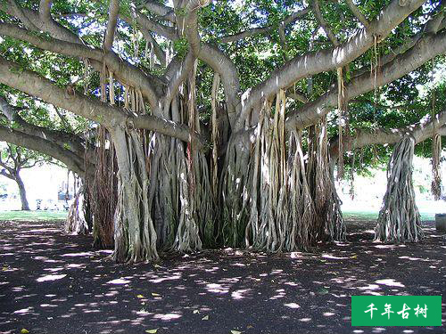

Financial Tree Theory believes that all mankind invention and creation are based on our
understanding and mastery of the natural laws. Trees are the master integrator of theses laws.

The reporter: Could you give us a few cases to illustrate price fluctuation, so we can get a better understanding of the system?
Prof Ding: We do not have to go very far back in time for a good example of this. When e-stocks began surging around the year 2000, I defied the trend and openly predicted its collapse. Sure enough, shortly after that, everything that I predicted had come true. Yahoo fell from 250 dollars a share to just several dollars. Between late 2002 and early 2003, dying internet companies were going bankrupt, and the stock price of the survivors had dropped to the lowest level. Even their operators held out little hope, under the circumstances. Due to my awareness of the economic cycle, I bought such e-stock and IT stock of Sina, Netease and Sohu at rock-bottom prices (0.5-3 dollars a share), which quickly rose to dozens of dollars. That is what I mean by fluctuation. The best theory of the stock market is the wave theory, in which stock prices are thought to change regularly in a wave pattern. In fact, it is the physical nature of the earth that determines why everything changes in a wave pattern.
This year, on May 17, I was invited to give a speech at the International Finance Conference. After the conference, a reporter asked me about which stocks to buy, and I told her to buy Mailyard and Handsome electronics, but that the market was rising too fast and would soon be adjusted. I bought these two stocks at more than 3 and 7 Yuan respectively at the end of 2006, and sold them at the high price of more than 20 Yuan, realizing over 3 and 7 times profit in the past 5 months. I bought the stocks back again at a low price after May 30’s sharp drop, and sold out in early September when price of the two stocks had risen by 8 and 15 Yuan(about twice or three times higher). Obviously, these two stocks had a good performance before and after the sharp drop, so if you did not hold such stocks or gained little before May 30, a great profit-making opportunity still existed after that time. Indeed, one of the most important factors influencing stock price is performance, and while the performance of these two companies was unsatisfactory, other factors existed which affected how the stocks performed. All of these are integrated into the Financial Tree model, which indicates past, present, and future value.
By making use of my imperfect knowledge of laws and characteristics of the earth and the universe, I have made uncountable accurate judgment and predictions about the future, and always adhered to my promise that I will be responsible for the objectivity, far-sightedness, correctness and accuracy of all my viewpoints and judgments throughout my life.

The reporter：Addressing the Shanghai Futures Investment International Forum on September 11, 2005, you pointed out: “In accordance with the Financial Tree theory, the “trunk’ of the United States was seriously unbalanced, and would have broken long ago, if not for its elasticity and flexibility. If this imbalance could not be amended, the whole tree may collapse before long, particularly if there are sudden and fundamental ecological changes. And if the United States collapses, the whole world will suffer. You added: “China is unqualified to have a systemic financial crisis.” What is the reason for this?
Prof Ding: Time and facts will tell. Both the latest financial crisis triggered by US subprime bonds, and the stability and rapid development of the financial industry in China during recent years, are the best test of my judgment and predictions, given above. Many countries suffered enormous losses in the global financial crisis, of which the most serious example is the United States. If the governments of the affected countries fail to provide a timely “blood transfusion” to save the market, the consequences will be unimaginable. A blood transfusion can prevent a patient’s condition from deteriorating and transfer the acute to chronic one. But if the illness cannot be removed completely, it will sow more hidden dangers for the future. Obviously the American monetary authorities, experts, and scholars simply do not understand the Financial Tree system; otherwise, such a crisis simply would not occur. The subprime bond problem was just the trigger of this systematic financial crisis. A few years ago, some economists at home and abroad predicted that financial crisis in China would be unavoidable. I pointed out in my articles on several different occasions that China is not yet qualified to have a systemic financial crisis. First, the financial industry in China is steadily developing. Second, the financial industry in China has not yet been systematized. How could an unmarried person have a marriage crisis?

The reporter: The invention of Financial Tree, Systematic Finance, and Financial Ecology will undoubtedly shake the whole world. Could you please sum up the role, value and significance of Financial Tree?
Prof Ding: Based on the insights of Confucius, Mencius, Copernicus, Darwin, Newton, Mao Zedong, Einstein and other great thinkers, Financial Tree, Systematic Finance, and Financial Ecology use the rules of the earth to reveal the objective laws of development from the perspective of the universe. Einstein's theory of relativity amended the view that space, time and gravity are independent of one another, and that the laws of motion remain immutable known since Newton time. Financial Tree Theory System believes that the laws of the earth as a unity not only govern the nature, but also everything on the earth. Once you grasp theses laws, you will know where things come from and go to. Therefore, Financial Tree provides a unique methodology for the development and management of everything on earth, stressing they must first comply with the laws of the earth.
Since my profession is finance and management, I am more intrigued by the roles, value and significance of Financial Tree to this field. First of all, it has unveiled the countless and logical relationships between “finance” and “tree”, which is an amazing discovery without precedent. On this basis, it integrates all branches of finance and management into a huge, clear and dynamic entity in accordance with natural laws—a great realization which is light-years ahead of current management theory and practice. It promises to thoroughly alter, for the first time in human history, the separately-developed history of accounting, financial management, finance and other subjects, by integrating all these subjects into an enormous (yet clear and simple) system of knowledge, management, and teaching. Secondly, it helps ordinary people grasp at a glance (in a few days rather than years) what would otherwise remain elusive, abstract, and arcane knowledge. Thus, they will be able to appreciate the mysteries of finance as easily as they enjoy films. Moreover, the popularization of Financial Tree will not only save a great deal of time and management costs for all humanity, but also avoid a large number of financial crises and management errors. Resolving the most complex issues through the simplest way is the ultimate goal of science.

The reporter: Asset pricing and risk management are core subjects in finance. Could you please illustrate the application of Financial Tree to theses aspects, through some actual cases?
Prof Ding: Sure. The Financial Tree Value System and Risk Management System combine all factors that affect assets, enterprises and even nations into a “tree.” It helps you make qualitative and quantitative analysis, so that you could easily pinpoint the origin and development of value and risk. If you can put all assets of a company at proper place on a “tree” according to the natural laws, and have some comprehension of the assets’ nature and relations in the system, then you will be able to discover any problems, and how to solve them, as easily as a doctor examining a patient. It is by this method that I had foreseen the collapse of some well-known domestic and foreign enterprises, such as Delong in Xinjiang and Enron in the USA. One night in 2004, a director of the CCTV Dialogue program invited me to attend a production. My lack of interest was enhanced when I was informed about the participation of a famous Beijing entrepreneur. When I told the director that the entrepreneur, and the well-known listed company he supervised, would have a major crisis, the director immediately asked for the head of CCTV’s instructions to notify him not to take part. Several months later, the crisis came up just as expected, during which the entrepreneur was not only dismissed, but subjected to severe punishment. His enterprise's stock plummeted, and the company was acquired by others. Imagine—a famous listed company ending just like this.
Almost all risks and crises (including the Sept. 11 attacks) could have been predicted before they took place by Financial Tree. And why not? Weather forecasters are able to identify future wind direction, wind speed and so on quite accurately. Everything has its own internal and external laws, which are dependent on those of the earth. Since trees are the synthesizer of heaven’s laws, Financial Tree can picturize these rules through the form of a tree, and put them into use.
Between 1992 and 1993, futures markets were springing up all over the country, on a large and spectacular scale. China's commodity futures exchanges grew out of nothing, and their quantity soon exceeded the rest of the world put together. After three months of investigation—at the peak of this craze—I went against the tide, and decisively suggested to Zhu Rongji (then vice premier) a series of recommendations and proposals for strengthening macro-control, and rectifying and standardizing the futures market. The implementation of these reforms warded off a financial crisis, saved the country a vast amount of funds and resources, curbed a huge loss of foreign exchange, restrained inflation to a certain extent, and promoted the orderly development of China's futures industry.
The fly in the ointment was the state's failure to shut down the bond futures exchange, which eventually led to its collapse and caused huge losses. Through Financial Tree model, you can see clearly how the various financial assets “grow” out of the branches of the tree. Futures are derivative securities, which are derived from the basic securities. Thus they “grow” on the treetops, and when a strong wind comes up, the top branches will be the first to suffer. This is why futures present the greatest risk and profit opportunities. At that time, China had not yet commanded sufficient expertise even over basic securities. How could we possibly do a good job in derivative securities? It is like a man who cannot walk, or even stand up without help, and yet is eager to run. A tree whose roots have not grown will not have any canopy. And there are still a lot of cases in which the practical application of Financial Tree in asset pricing and risk management has been shown.

The reporter: The actual situation of individual corporations differs in thousands of ways, and as the saying goes, "One key opens one lock." As a visionary theoretical system, how does Financial Tree solve the practical problems of these enterprises?
Prof Ding: As I’ve said, Financial Tree is capable of synthesizing all elements that influence any business, industry or even nation. It does this through systematic qualitative and quantitative analysis. When stated in the form of a Financial Tree, each enterprise's practical problems and solutions will be evident. Just as hospitals are able to provide medical treatment to different people, so can Financial Tree assist different enterprises.

The reporter: "Financial Tree" is a gigantic theoretical system. What are its limits? We know for example that Newtonian mechanics cannot explain quantum phenomena. Is there is any field which Financial Tree cannot explain？If so, what? How to perfect?
Prof Ding: A very good question. Currently, the Financial Tree is not only vast theoretical system, but also a huge management and teaching system with many subsystems. Other systems are likely to come out of it, since the theory is so universal and open-ended. Its theoretical boundary lies in awareness and understanding of the laws and characteristics of the earth and the universe. As I mentioned earlier, the earth as an entity by itself is a part of the entity—the universe, and everything is interlinked. So compared with the earth and the universe, the financial world is only a friction—all of its laws and events are subordinate to those of the former. Therefore, no subject in the entire financial world lies beyond the scope of Financial Tree. But that does not mean that it is absolute and omnipotent, for the whole world is relative. Therefore, just as the comprehension of human beings toward the earth and the universe, the “Financial Tree" always has much farther to develop.

